|  |
| --- |
| NTNU mARINE TECHNOLOGY DEPARTMENT |
| Role of human and organizational factors on the safety of Marine and offshore operations |
| Course Work for PK 8201 Reliability of Safety-Critical Functions |
|  |
| **GUNNU GIRI RAJA SEKHAR** |
| **6/14/2009** |

**Is there any impact of human factors on the maritime domain?**

**If yes, how does it influence?**

**Is that impact is considerable?**

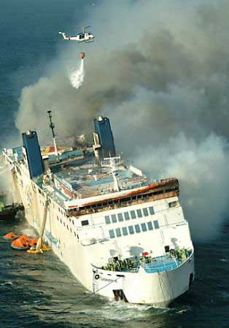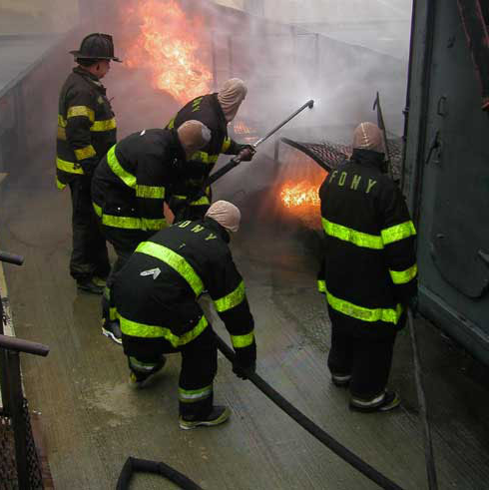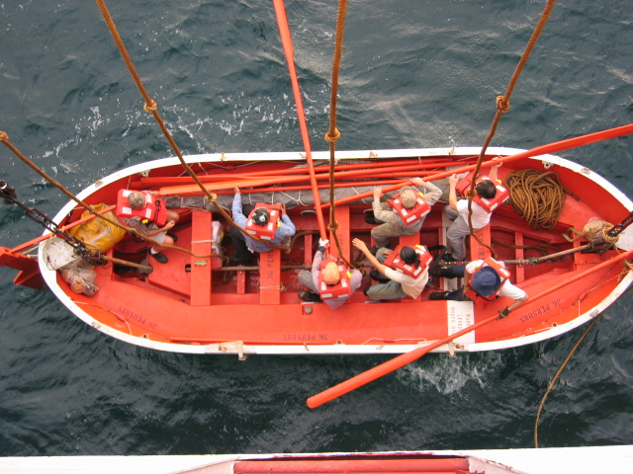

**(Fire Accident) (Fire Fighting) (Escape through life boat)**

|  |
| --- |
| The article is representing the level of understanding of Reliability of Safety –Critical Function. The main focus of this document is describing the human factors influence in the safety of marine systems in the recovery stage. In simple word answering above questions. |

(Source: Pictures adopted from Google search)

**Role of human and organizational factors on the safety of Marine and offshore operations**

**Abstract**

The objective of this paper is to represent the level of understanding of Reliability of safety critical functions in a short description. The main focus of this report is to represent the influence of human and organizational factors in the safety of marine operations. Traditionally human factors in maritime domain can be studied through accidental/incidents analysis. On the other hand there is a drawback with traditional approach, sometimes it may not reveal the human factors that do not induce accidents/incidents earlier but in future it may govern to happen. Modern systems have adopted intelligent technology in safety critical systems (like automatic fire detection, fire extenuation etc). Human and technology are jointly responsible for safety of the above systems. The safety level in the marine industry can be enhanced by improving the human performance. Our intention is to prevent or mitigate the accidental consequence. It can be achieved through improving the performance of the human factors, organizational, improving the reliability of the components and/or increasing the reliability of safety instrumentation function or the combination of the above. The focal point of this case study is to discus about the human performance on safety of ship operation; it addresses both an individual level and organizational level. To illustrate these points, I considered emergency escape of cruise ship due to fire. How the human error can be minimized by implementing suitable design and regulation are explained briefly. What precautions can be taken by the organization to minimize the errors are not covered in this report.

**Key words:** Human factors, Maritime domain, Safety, Organizational factors, Emergency escape, Fire

**Introduction:**

**System Reliability:**

System reliability has taken considerable steps to reach the present stage. The progress of System reliability can be considered in three stages. At initial stage engineers, mathematicians and reliability analysts are widely concerned about the technical errors on the system failure. The accidental investigation at this stage is carried out by the group of engineers or experts from different fields (Offshore engineers, Naval architects, Mechanical, Material, computers etc). These experts will identify the catalog of the failures (what are the component has failed) and the root cause behind the failures (why the components has failed). As result the data gathered in the investigation can be used to upgrade the design in component level and the system level.

Latter in the second stage the accidental instants in the nuclear industry like Flixborough (1974), Seveso (1976), Three Mile Island (1979), Bhopal (1984), Chernobyl (1986) incidents are increased the awareness of the human errors and human reliability in the system failures. It is identified that each of the above incidents are happened due to different types of human errors and failings; some of them were not generally recognized prior to the incident. These incidents have alarmed the analysts to incorporate the human errors and the actions in the Probabilistic Safety Assessment (PSA). Even though the above incidents are related to nuclear industry the same philosophy can be extended to marine industry. This stage the human performance investigation is carried out in addition to the technical investigation. More often the human performance investigation is carried out by single (individual) person, who may be or may not be trained in the human factors. The intervention aimed on human factors are typically derived by well-meaning, “expert” opinion or group discussions about many “believe” are the major safety issues. It appears to be that the safety due to the human factors is prone to the expert judgments instead of data driven; apparently the safety strategies are marginally effective for reducing the occurrence and consequence of the human error. The levels of human performance and errors are addressed in section 3.

As stated earlier until 1980 both the public, organization and the accidental investigator focus is mainly on individual level in order to punish the person who commits an error. In response the core points of the research topics are the cognitive, perceptual and physiological demands that new generation of automated systems placed upon their operators. Unfortunately this approach is not adequate enough address the system failure that can lead the accidents like Challenger (1986), Piper Alpha (1988), Hillsborough Stadium (1989), Narita (1994) and consequence of sea empress disaster in Milford Haven in 1988. In order to address the reason behind the above accident the analyst focus is moved towards the managerial and organizational level instead of only lower level like human performance (Figure 1).

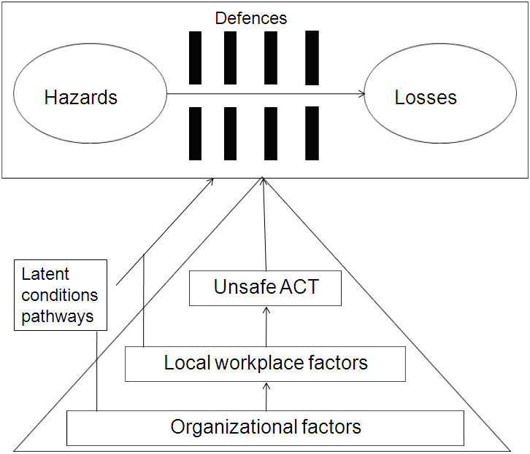

Figure 1: Stages in the development and investigation of an organizational accident

*Source: adopted from James Reason (1997)*

The comprehensive theory behind the system accidents is explained by the Reason’s Swiss cheese model. In accordance with this theory the holes in the layers of safety barriers (layer of defenses or safe guards) can be created by active and latent failures. The human contributions behind the above failures are classified into four levels, each of which corresponds to one of the four layers contained in the Reason’s model (Refer Figure 2 and Annexure 1). These are 1) unsafe acts (Refer Figure 3), 2) Preconditions for unsafe acts, 3) Unsafe supervision, 4) Organizational influence.

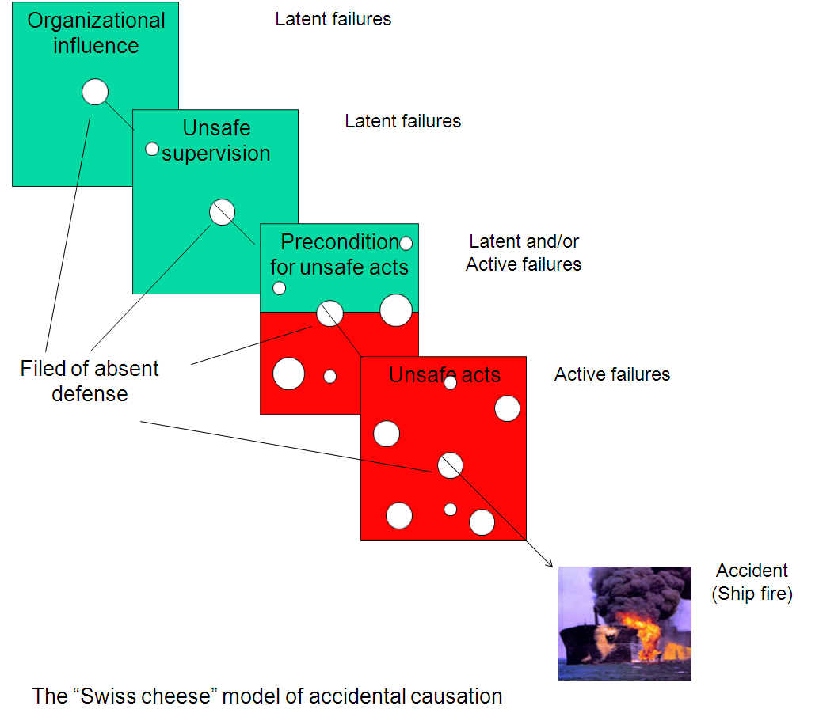

Figure 2: The Swiss cheese model of accidental causation

*Source: Adopted from reason (1997)*

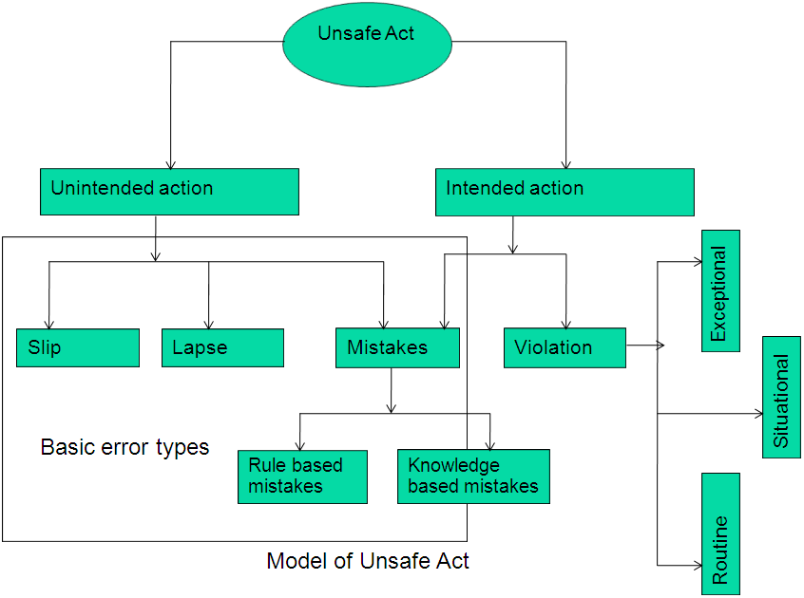

Figure 3: Model of unsafe act

*Source: Adopted from Reason (1990)*

**Human performance and error types:**

Reason (1990) and Rasmussen (1982) has stated human performance can be classified into skill-based (SB), rule-based (RB) and knowledge-based (KB). The corresponding error types are explained here (Figure 4), as skill-based slips (and lapses), rule-based mistakes and knowledge based mistakes.

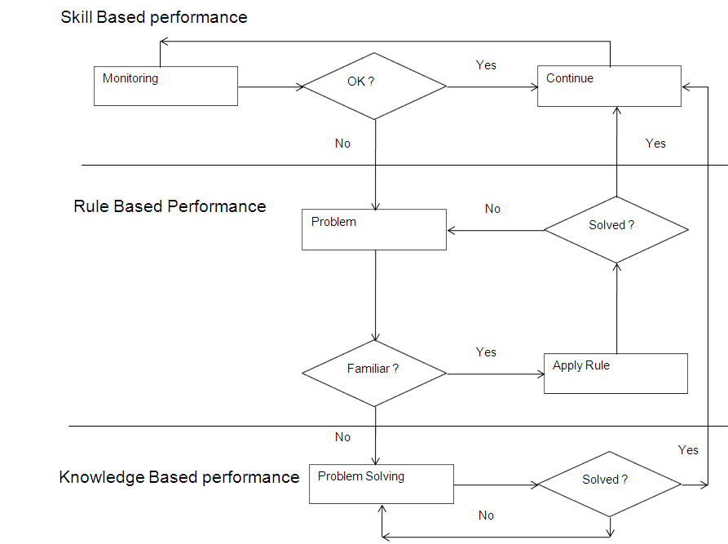

Figure 4: Human performance model

*Source: Adopted from reason (1990)*

Skill-based responses are highly routinised responses in familiar circumstances; these responses are mostly physical reactions that take little thought. The skill based errors will occur if the skills are not sufficient enough to handle the particular goal oriented task.

The RB level is engaged when an attentional check up progress detects a deviation from the planned- for condition. RB attempts take actions based on the rules that govern particular actions and are largely automatic, similar to SB actions. The appropriate rules are varies with respect to the situations in the RB performance. RB errors occurs while misapplication of good rules or the application of bad rules to the situations.

Knowledge based behavior is event specific, and is based on functional understanding of what is happening in the system when a demand is placed on the operator. This level of behavior involves higher-level cognition processes-identification of system status, decisions based on the goal such as production, safety, etc., and task planning. The planned task calls upon rule-based behavior for stored procedure and skill-based behavior for execution of the task (Figure 5).

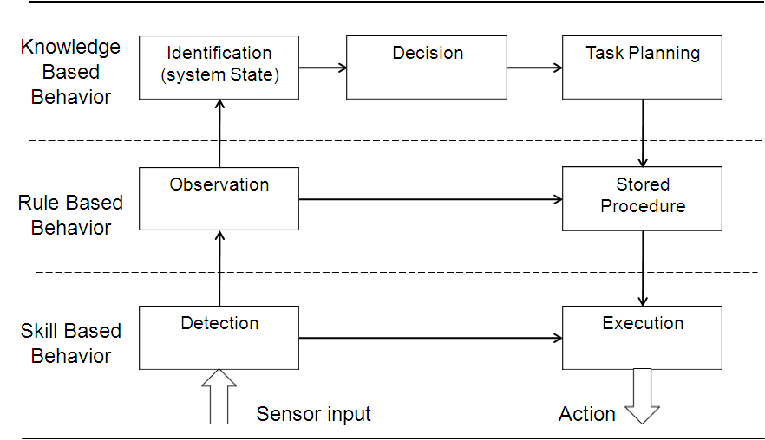

Figure 5: Skill-based, knowledge-based and Rules based behavior.

*Source: Adopted from (Rasmussen et al, 1981)*

The perspective of human errors in the aviation field is categorized and explained by Douglas. A and Scott. A (2003). Based on the above information same way these errors can be categorized in the maritime field into six major categories; order wise they are cognitive, ergonomic, behavioral, seasickness, psychological and organizational. Different human error perspective gives different level of understanding of the problem and solution approach

Human error models and error taxonomies were developed to categorize and explain human failure during major accidents. Human reliability analysis is concerned with the qualitative and quantitative analysis of human error and its subsequent reduction. Unfortunately predicting of human error is not an easy task and as a result the human reliability analysis itself has it’s own difficulties when demonstrating about accuracy and validation. The studies have to be developed to minimize the large-scale accidents in complex systems like nuclear power, chemical, commercial aviation and offshore industries.

Human performance and human errors (increasing or decreasing) are direct control by the performance shaping factors (PSFs). Human error probabilities (HEPs) can be determined by means of identifying proper PSFs (example: available time, Stress, Experience, Training, etc.).

**How to obtain the human error**

In the first look if we see data collection in macro level it appear to be simple and not a problematic; it look like all we need is information about human behavior and errors. When we dig into the micro level it gives the real feel of the complexity of data collection. The purpose of the data collection is to provide all necessary information for the analysis being undertaken. The type of information required depend on the safety of the system we look. Even for the same operation it may vary for different organizations. For example, in order to study safety of specific operation the information about errors related to this operation is sufficient enough.

Traditionally data is collected through the accidental analysis. Luckily some of the earlier incidents may not lead the sever consequence it may prone to happen in future. Hence it is essential to collect the data from near miss incidents. In addition to above the incidents data gives understanding about the human errors and human behavior in the system. The disadvantage with the traditional approach is sometimes it may not reveal the human factors that do not induce accidents/incidents earlier but in future it may govern to happen.

**Safety, Risk and Reliability:**

It is useful to clarify the distinction between reliability and safety before going to discuss about safety critical functions. When we talk about the safety of systems we are interested in the safety of complete system. This is comprised of interacting lower level systems, such as instrumentation, Computer systems, controllers, hard ware, and human interactions and so on.

Marine operations are high demand systems the reliability is expressed as probability of failure per hour.

Safety is a quality or a characteristic of the system. It is defined in terms of “freedom from unacceptable risk” in IEC 61508, where risk is defined as ”a combination of probability of occurrence of harm and the severity of the harm”. The combination is interpreted to be “multiplication” if the two intuitive parameters used may be multiplied and the values are reasonably found. The probability notation itself intuitive: it is an indication of ‘our intensity of conviction’ or ‘the likelihood of an expected event occurring’. Instead of the above mathematical approach alternative generalizations like Bayesian view or Damper-Shafer belief function can be used. In Bayesian view the probabilities are subjective values (Expert’s opinion, some back ground information when there is no previous data) and Bayes law is mechanism for “changing one’s mind”.

The safety of marine systems are expressed in terms of free from the occurrence of accidents, i.e. from the undesired events that lead to catastrophic consequences such as fatalities or injuries, environmental effects and property loss. The top of the organization have a pivotal role in maintaining safety culture. In general the safe organizations are productive and profitable and the cultural values which give emphasis to safety also support commercial success. The safety functions are to be performed by the system along with the safety objectives, integrity, functional, performance and regulatory safety requirements. The distinction between the safety objectives and safety requirements is made because certain operational and environmental mitigation can be taken into account in formulating the requirements. The relation between the safety objectives and the safety requirements can be represented by the Figure 6. The risk reduction can be achieved by either external risk reduction facilities, other technology safety related systems and safety instrumented systems.

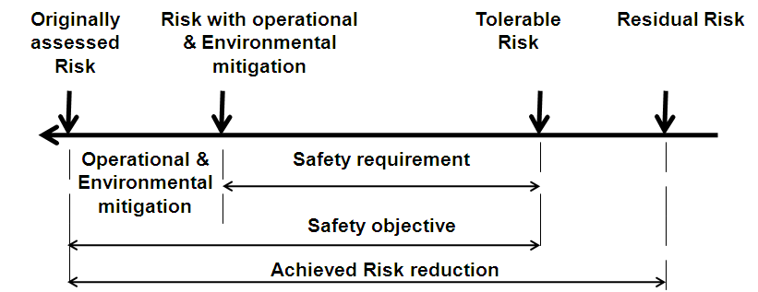

Figure 6: The Relationship between Safety Objectives and Safety Requirements

*Source: Adopted from the safety of systems*

**Marine operations:**

Today over 90% of world cargo is transported by merchant ships. Statics reveal that the number of ships increased from 30,000 to about 90,000 between 1990 to end of the century. Public and governmental bodies are concern about safety of marine industry, especially in the application of relatively new marine technologies. New marine systems complexity is 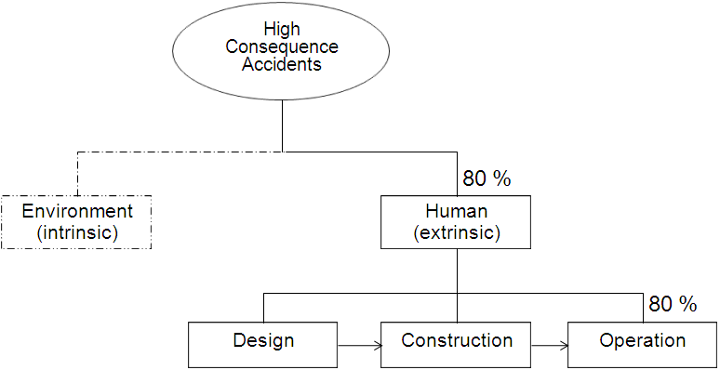

Figure 7: Causes of high consequence accidents

*Source: Picture is adopted from 1996 International Workshop on Human Factors in Offshore operation*

increased rapidly at the same time the number of systems also increased. Modern ships are equipped with advanced technology like fully automated systems etc. Although these are advanced still a degree of human intervention (like respond to fire alarms, life boat releasing etc.) is required directly or indirectly. These systems are producing new hazards. In order to understand the above system we need lot of inputs and outputs. Technology is changing faster than the engineering techniques to cope with the new technology are being created. It is very difficult to understand the functionality and limitations of the above systems by a single person. Sometimes it may be required to inter act the humans with other humans for maintain the functional safety of the system. As we know the humans are not 100% reliable, the past experience says that around 80% accidents are happening due to human error.

It is not possible to eliminate all risk in marine domain but it can be reduced by implementing suitable risk reduction measures. Many of the risk identification methods are used in the maritime domain, some of them are indicated in the figure 8. The Japan Marine Accident Inquiry Agency is classified Merchant ship accidents into 16 categories, those 1) collision, 2) collision (single), 3) grounding, 4) foundering, 5) flooding, 6) capsize, 7) missing, 8) multiple accident, 9) fire, 10) explosion, 11) machinery failure, 12) equipment damage, 13) facility damage, 14) death and injuries, 15) safety hindrance and 16) navigation hindrance. Out of the above accidental categories fire and explosions are one of the major accidents. This can release the dangerous substance involving death or serious personnel injury to persons on board. Due to the above reasons fire is considered is the accidental scenario in this report.

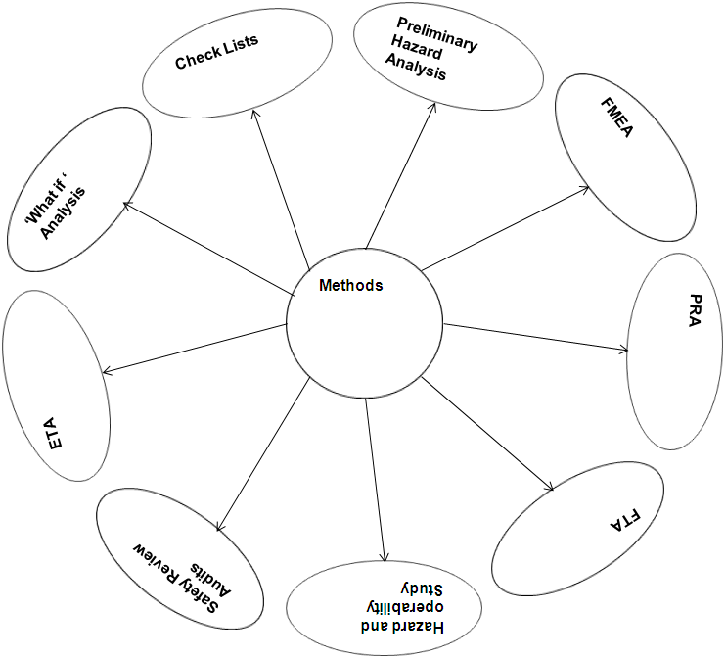

Figure 8:Methods for performing risk analysis in the marine systems

*Source: Adopted from Dhillon (2007)*

Risk mitigation can be achieved by implementing suitable risk reduction procedure like evacuation etc. In order to mitigate the impacts due to fire, collision etc. The emergency response may be required to mitigate the impacts. Active errors may occur while doing the evacuation (incorrect release of a lifeboat) and some of the latent errors already exited due to maintenance of fire detection system, or/and lifeboats and life rafts may occur but they would not reveal until the demand occurs (example ballast pump unavailability when required). Many accidents consequence would have been reduced if the right actions had been made at the right time and in the right place. The available time window is less so the crew has to prepare for emergency operation. This can be achieved by necessary planning and training proactively. before something undesirable happens.

**Human errors in Maritime domain:**

When we say there is a human error influence on marine operations. Those who are not familiar on this domain they get following doubts:

Are there really human factors impacts on the maritime domain?

If yes, how does it influence?

Is that impact is considerable?

Investigation reports on the accidents and incidents are one of the ways to show the presence of human factors influence on the marine activities. In fact the human intervention is there everywhere of the life cycle of an operation (beginning from design, build, operation) either directly or indirectly. As it was mentioned earlier the impact level varies for operation to operation and even organization to organization. These effects indicated in a risk level in order to express how severe it is. Our

The intention of a research fellows and the organization working on the risk analysis is how to increase safety. In order to improve Marine safety we first have to answer the question: what is the safety in true sense?

To get clear view we have to split the above question further into three sub questions:

What is the safety all about?

Why system safety is necessary?

What do we need for system safety?

Safety can be improved by either reducing / mitigating the risk. Chen (2003) has explained the risk analysis can be divided into initiating stage and the recovery stage. Unlikely the systems having zero threats, so there is no chance to avoid 100% accidental events. The frequency of consequence can be lowered either by deploying suitable risk reduction methods or increasing the number of protection layers (barriers) between the hazards events and the consequences (Figure 9). Sklet(2006) has explained the types of barrier and their performance measures (Figure 10 ). The focus of this report is identification of the human factors influence on the recovery stage barriers. The performance of this can be improved by implementing suitable procedures few of them as indicted bellow:

* Learning from the data and reducing the events in future.
* Taking corrective action on the information collected
* Improving the collected information quality
* Procedure to be established for measuring the behavior

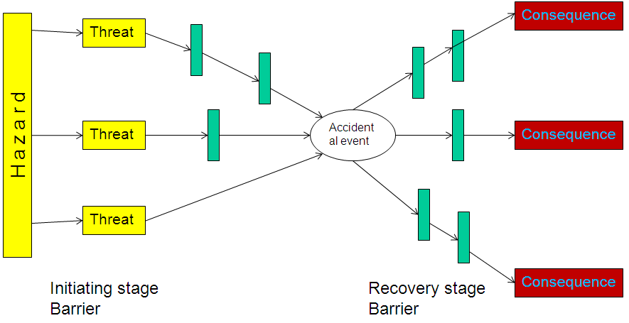

Figure 9: Illustration of barrier significance in the risk analysis

*Source: Adopted from Trbojevic (2001)*

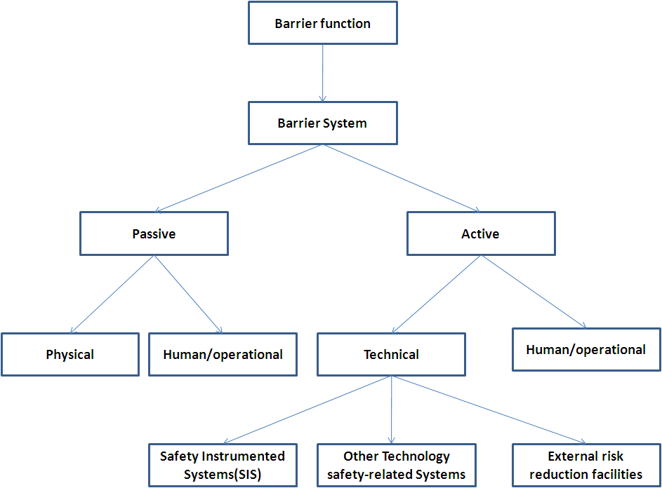

Figure 10: Classification of safety barriers

*Source: adopted from Sklet (2006)*

The key considerations in the operations are Health, Safety and Environment (HSE) plan, risk management, job safety analysis, environment impact study, job and safety training. The safety and reliability of the operations are relied on the experience of the operators or skippers. It is possible to reduce the risk level or improving the safety of the operations by increasing the knowledge of the operators. The earlier accidents analysis gives some understanding about the failures causes and interaction effects between human and technical factors, organizational factors. These factors leads to undesirable events like serious injuries to crew/officers or fatalities, damage to the property. In order to improve the safety level the following accidental causes are to be minimized:

* Lack of knowledge about the operation
* Lack of understanding about the behavior of the crew and passenger
* Poor planning and risk analysis
* Lack of situation awareness for decision making
* Communication gap between the crew
* Human behavioral factors like shortcuts, negligence, taking chances, working environment / work load, allowing frustration actions and procedure errors.
* Lack of team effort)
* Design errors

**Is there any chance to reduce error? If yes how can we reduce the errors?**

In the past industries are carried out human errors analysis in order to punish the person who commits an error. Most of the time analysis was carried out after the accident. Sometimes the near misses give enough understanding of the human errors in the system. Even though these misses has not reached the level of severe consequence level in future these errors may lead to new accidental scenarios that may lead to high consequence level. So, it is better to learn as much as we can from the near misses. This information can be utilized in the risk analysis in order to take suitable decisions in future. Unfortunately on the other hand lack of information on the near misses due to the organizational methodology of punishing the persons those committed errors. So, the individual approach to reduce the human error is not as effective as system approach of reducing error such as Safety Management System (SMS). SMS approach of identification of system error is comprehensive; the focus is in the individual, team, the unit and the organization.

The major consequence can be either avoided or reduced by taking the correct action after the accidental event. In general the available time window is less in the high demand system. In order to take a correct action in the operator should have sound knowledge about safety function of the system and their limitations. This can be achieved by improving their knowledge on the operations by giving proper training. Crewmembers must not only be individually trained, they should train as a team. This will help the crew to work as a team and improve communications since they will both be on the same page. Communication between crewmembers must be effective and efficient. Crews that communicate well can raise situational awareness and can improve the timely notification of errors so that the consequences of errors can be avoided.

In addition to the above factors organization management policies and emergency and life saving regulations are to be improved.

**Case study:**

**The accidental modeling approach:**

The accidental modeling approach is to have an overall picture of the events from the initiation to the final outcome. The accident events are divided into five categories, namely human error, equipment failure, hazardous materials, environmental factors (waves, wind, fog, tides etc.). In fact the root causes of the accidents events are consequences of short coming of persons, job conditions and management.

The accident can be happed in many ways as mentioned earlier; it is not possible to study all at the same time. Fire, Contact and collision, and Loss of hull integrity are considered as an accidental event. The author main focus is on the risk reduction on the recover sate of the operation. Here the safety function at the recovery stage is evacuation. Cruise ship has considered as an example to describe the human error influence on evacuation process. In general the risk level in cruise ship is more than the merchant ship. At the same time public is more concerned about cruise ship accidents than the other types of merchant ships. The incidents result from either crew errors or performance problem with the ship (fires, etc.).

Figure 11 and Figure 12 explains the sequence of undesirable elements in marine operations. The chain of events begins with hazards capable of causing causalities. If these are no hazardous then there are no causalities. The origin of the hazards is an equipment failure, human error, or external events. Sometimes even one or more equipment failures, human errors or external events take place after the initiating event. The effects can be minimized by improving the safe guards (barriers). Causes are the underlying reasons why the initial incidents occur and safe guard failures allow the chain of events to progress. These are called root cause of the accidents. Here few of the events in the above model are considered. The no events and the level of influence is varies for each case.

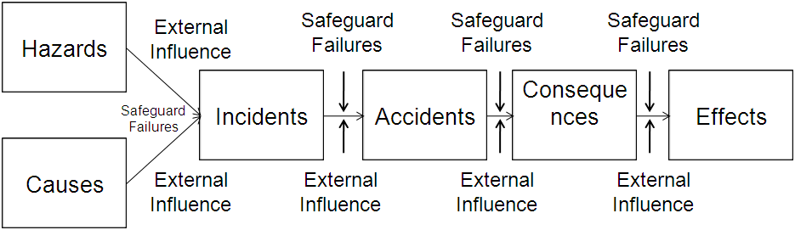

**Figure 11: Characterization of elements of marine risk scenarios.**

***Source: Adopted from Principles of Risk-Based Decision Making***

**Accidental Event (FIRE):**

Fire is a major accidental event in ships. The level of risk involved, the potential costs of a fire spreading outside the space of origin can be enormous. Although their frequency of occurrence is relatively low in passenger ships, several accidents occurred in previous years with far reaching consequence from which the Scandinavian Star is the ultimate case. International Maritime Organization (IMO) has expressed “fire also represents a particular vulnerability for large cruise ships and every passenger is a potential ignition source and the hotel services have an inherent risk”. In addition to the above potential existence of dangerous goods also cause fires.

Fire can be seen as any condition involving evidence of fire, smoke, or an impending explosion. This would include the sighting of smoke or fire, odorous evidence of burning, or concentrations of flammable gases. The fire triangle consists of fuel, oxygen and heat. All three must be present to start a fire and the removal of any single one can extinguish a fire. Fuels, such as gasoline and propane, can be very dangerous if precautions are not taken. The smokes of these fuels are heavier than air and tend to collect in the cabin, bilge and other lower areas of the vessel. Small leakage of these fuels in the engine rooms is frequent, increasing the probability of an accident.

**Fire spread can be minimized by applying suitable actions at suitable time. After identifying the location of the fire and severity level type for fighting method is decided by the master. The effectiveness of the fire control directly depends on the human performance and technical factors.**

Figure 14: Illustration of human performance on marine evacuation

*Source: Adopted from A. G. Eleye-Datubo (2008)*

The spreading of the fire depends on human (active errors and latent errors), technical and physical (Some of the technical and physical aspects covered by SOLAS). Some of the influencing factors are listed below:

* Management could not able to provide sufficient fire fighting facilities
* Crews are unfamiliar with the ship
* Crews are not familiar with the new systems
* Crew could not act in time to put off fire
* Lack of experience and skills of the master while the ship is emergency conditions
* Lack of knowledge about reason beyond the fire
* Lack of knowledge about fire spreading
* Delay in identification of the fire
* Lack of fire doors,
* Lack of maintenance in the fire detecting system and sprinkler system
* Fire doors are not locked
* Lack of coordination

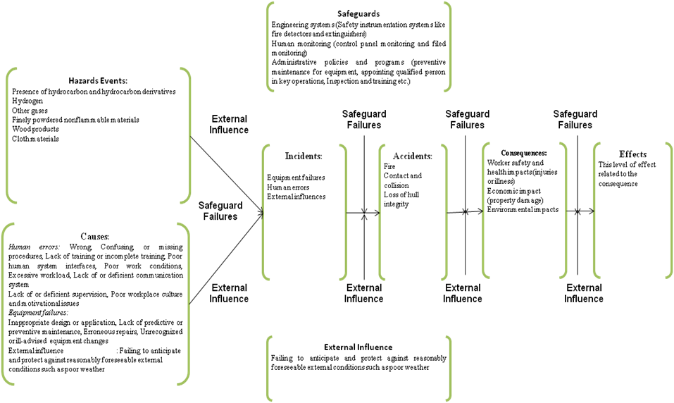 *Figure 12: Illustration of human influence on the accidental sequence*

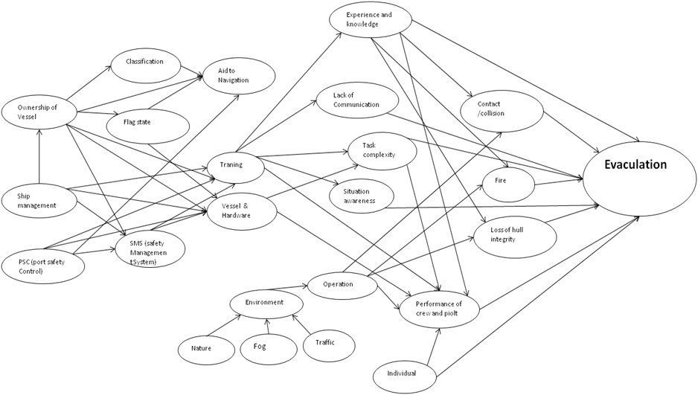

*Figure13:* *influence diagram of marine operation*

**Evacuation:**

It is not possible to have system with 100 % reliability, so always there is a chance of accidental events. The human performance factors on the accidental event (fire) is explained earlier, similarly we can investigate human performance on other types of accidental events. Evacuation is considered as a safety function. When the accidental event spreads beyond the safety margin level rescue operation will be carried out in order to reduce the effects. Life boats and life rafts are used to rescue the people. The efficiency of the rescue operation depend on the technical facilities available an onboard and the crew. Few of the influencing factors on the evacuation process are listed below (Figure 13 and Figure 14):

* Crew could not able to pass the fire information to the passengers
* Could not able guide them to the escape ladders
* Lack of emergency training to the crew
* The emergency plan is not sufficient to address the relevant scenario
* Crew could not understand the passenger’s language
* Communication gap between the crew
* Crew has not trained as group for working in emergency conditions
* Emergency equipment and system were not up to date
* Poor quality of escape plan
* Lack of maintenance in life boats and life rafts
* Partly in adequate sound level of the alarms
* Emergency signposts was incorrectly located and not in a Passengers language
* Deficiencies in alarm systems
* Poor technical arrangement of escape ways

The influence of human and organizational factors on the safety of marine operations can be explained by influence diagram. This is a qualitative analysis. In general the influence factors are can be expressed in an objective way. The quantification can be archived by either converting the above diagram into Bayesian net work or other suitable method. The report is not focusing on the above methods..

**Designer role in Emergency and Life saving appliances:**

The designer should consider the human reaction in emergency situations for designing the life saving appliances and escape procedures. The ship designer has to be considered following aspects in view of operators like operations, passenger & crew safety, systems maintainability, task complexity and over all human performance.

* Stair/ladder design, orientation, location, size and type
* Layout, orientation and design of operator console, control panel, display and alarms
* Location, orientation and access to valves and valve handles
* Location or orientation of equipment, furnishing, and structures
* Accessibility to equipment for operation, maintenance or removal
* Personnel and material movement for normal and emergency conditions
* Equipment labeling, significance instructions and warning, operating guide lines, and alarm
* Passage way or walk way clearance and flow
* Indication/marking of escape routes
* Human machine interference (information from control and display)
* Accommodation design

**Regulations Role in Emergency and Life saving Appliances:**

Chapter III of SOLAS regulation is covered the requirement of Life saving and arrangements. The regulation is focused on design requirements and guidelines for operation.

International Safety Management (ISM) was created by the IMO. This Code is differs with respect to the past international regulation; this is concerned about the ‘human ware’ the people and the systems instead of hardware. The purpose of this code is to “provide an international standard for the safety management and operations of ships and of pollution prevention. The plan includes plans to train ship and shore –side personnel, ensure safety practices, respond to emergencies, prevent pollution, correct ISM non conformities, and name a Designated Person responsible for ISM Code observation.

* The company should establish programmes for drills and exercise to prepare for emergency situations.
* The safety management system should provide for measures ensuring that the Company’s organization can be respond at any time to hazards, accidents and emergency situations involving its ships.
* The company should define the responsibility of the shipboard personnel and ensuring each of them is properly trained to perform their duties safely and efficiently.
* The company should have clearly defined plans for dealing with emergencies, for monitoring, reporting and analyzing accidents and hazardous occurrences to ensure proper corrective action.
* The company management should establish sound procedures for maintaining the ship and its equipment in a safe condition.
* The company should establishing safe guards against all identified risks.
* And it is about to self reliance and self regulations of auditing systems once it has been established.

Marine officers are trained for handling emergency situations where damage or loss of crew or vessel is likely to occur. Such situations require both skill-based and rule-based operation. Experience with operation performed, combined with available online measurements of some systems states, and possibly input from task planning, improves the understanding and cognitive identification of systems states. Thus, knowledge-based behavior may take place to certain extent in emergency situations. The researcher’s goal is to improve the level of knowledge-based behavior during future operations with subsea systems.

**Conclusions:**

* Cree knowledge and experience is required in order to reduce the risk level. One of to achieve this by providing suitable training as an individual and as a group.
* Emergency drill has to be conducted in order to check the equipment conditions and the crew awareness on the usage of equipment. This can minimize the relay on the failure equipment.
* The advantage of the safety analysis implementation in the operations yields reduction of human injuries, improvements made the performance of tasks easier, increases operation duration and increases safety awareness.
* It provides information about weakness in the systems and areas where risk remedial measures have to be implemented
* Study the near miss accidents for clues to unidentified hazards or accidents causal factors
* Risk can be minimized by implementing suitable safety management systems
* Emergency escape appliances are to be designed by considering human behavior in at the time of accident.
* Ship management has to follow the national and international safety regulation.
* Regulations has to be updated in order to cover the worst accidental scenarios and the role of human

**The challenges to the researcher:**

* Effective training procedures have to be developed by considering the real accidental scenarios.
* Role of organizational factors are to be explored further.
* Human behaviors at the time of accident should be explored father.
* Appropriate data collection system and data analysis system has to be developed
* Ergonomics and control panels have to be developed in view of operators.
* Develop methods and tools for identification of system states in order to establish knowledge –based behavior
* Suitable emergency procedure should be developed
* Suitable decision making system should be developed which can predict hazardous situations and suggest correction before emergency occurs

**Limitations:**

* The quality of safety analysis is depends on identifications of hazards, variations in the available failure data, quality of real time simulations results and quality of expert judgment.
* The safety influence factors are considered based on the available information. It may be possible to miss out certain factors. The influence of missed parameters may be sufficient enough to increase the level of risk

**References:**

1. G. Eleye-Datubo, A. Wall, A. Saajedi, and J. Wang. Enabling a Powerful Marine and Offshore Decision-Support Solution Through Bayesian Network Technique. Risk Analysis, Vol. 26, No. 3, pp. 695-721, 2006.
2. Antão P, Guedes Soares C. Causal factors in accidents of high speed craft and conventional ocean going vessels. [Reliability Engineering & System Safety](http://www.sciencedirect.com/science/journal/09518320), 93(2008), pp. 1292–1304.
3. Chen H and Moan T. Probabilistic Modeling and Evaluation of Collision bet­ween Shuttle Tanker and FPSO in Tandem Offloading. Reli­ability Engineering and System Safety, 84 (2004) 169-186.
4. Chen, H(2003) Probabilistic evaluation of FPSO-tanker collision in tandem offloading operation. Dept.Marine Technology(pp.141) Trondheim: Norwegian university of Science and Technology URN:NBN:no-3369
5. Dhillon, B. S. (2007), Human Reliability and Error in Transportation Systems, Springer London.
6. Endsley MR. Toward a Theory of Situation Awareness in Dynamic Systems. Journal of Human Factors, 37(1) (1995) 32-64.
7. IEC 61508 (2002). Functional Safety of Electrical/Electronic/Programmable electronic safety-related systems, Part 1: General Requirements, BS EN 61508-1:2002. British Standards, 2002.
8. IEC 61508 (2002). Functional Safety of Electrical/Electronic/Programmable electronic safety-related systems, Part 6: Guidelines on the application of IEC 61508-2 and IEC 61508-3, BS EN 61508- 6:2002. British Standards, 2002.
9. Leveson, N. (2004): A New Accident Model for Engineering Safer Systems. Safety Science, 42(4): 237--270.
10. Prevention in the Process Industries, 19 (2006) 494-506.
11. Rasmussen, J. (1997): Risk Management in a Dynamic Society: A Modelling Problem. Safety Science, 27(2/3):183--213.
12. Reason J (1997). Managing the Risks of Organizational Accidents. Aldershot, United Kingdom, Ashgate.
13. Reason, J. T. (1990). Human error. Cambridge, U.K.: Cambridge University Press.
14. Redmill and Anderson, Human Performance Improvement – Reducing Significant Events in Nuclear Power, Improvements in System Safety, Proceedings of the Sixteenth Safety-critical Systems Symposium, Bristol, UK, 2008
15. Rosness R. Risk Influence Analysis, A methodology for identification and assessment of risk reduction strategies. Reliability Engineering and System Safety, Vol. 60, pp. 153-164, 1998
16. Sklet, S. (2006) Safety barriers: Definition, classification, and performance, Journal. of Loss
17. [Trbojevic, V.M., Linking Risk Assessment of Marine Operations to Safety Management in Ports, 6th Biennial Marine Transportation System Research and Technology Coordination Conference, Washington DC, 14-16 November, 2001.](http://www.risk-support.co.uk/vmt_MTS2001.pdf)
18. Uchida, M.: Analysis of human error in Marine Engine Management. In: Advances in International Maritime Research. Proceedings of Annual General Assembly No 5. Tasmania,IAMU, 2004, pp. 85–93.
19. Vladimir M. Trbojevic and Bellamy L J, Risk Assessment in the design process
20. Vladimir M. Trbojevic, Linking Risk Assessment of Marine operations to safety management in Ports
21. WANO Guideline, Principles for Excellence in Human Performance, WANO-GL 2002-02
22. Wenche K.Rettedal, Terje Aven and Ove T.Gudmestad. Integrating QRA and SRA Methods Within a Bayesian Framework When Calculating Risk in Marine Operations: Two Examples. Journal of Offshore Mechanics and Arctic Engineering, Vol.122, pp.181-187, 2000.
23. Wiegmann, D.A., Shappell, S.A., 2003. A Human Error Approach to Aviation Accident Analysis. Ashgate Publishing Co, Aldershot, Hants, UK.

***Annexure 1: Detailed Accidental Causations***

**Unsafe act of operators:**

**Errors:**

*Skill-based errors:*

Break down in visual scan, Inadvertent use of ship control, Poor technique, Over-controlled the ship, Omitted check list items, Omitted step in procedure ,Over – reliance on Automation, Failed to prioritize attention, Task over load, Negative habit, Failure to see and avoid, Distraction

*Design Errors:*

In appropriate maneuver, In appropriate procedure, In adequate knowledge of system and procedure, Exceed ability, Wrong response to emergency

*Perceptual error*

Due to visual illusion, Due to spatial disorientation, Due to misjudged distance, altitude, speed and clearance

**Violations:**

*Routine*:

Failed to use radar advisories, Flew an unauthorized approach, Violate training rules

Failed to comply departmental manuals, Violations of orders and regulations

*Exceptional*:

Performed unauthorized maneuver, Failed to obtain valid weather brief, Failed to complete performance computations for ship, Exceed ship limitations, Accepted unnecessary hazard

**Precondition for unsafe acts:**

Physical environmental factors, Technical environmental factors, Personnel factors (crew resource management, and personal readiness) and conditions of the operator (Adverse mental states, adverse physiological stages and physical/Mental limitations).

**Physical Environment:**

Weather, lighting, vibration, Ship motions etc

**Technical Environment:**

Equipment control design, Check list layout, Display/interface characteristics, Automation etc.

**Crew resource management:**

Lack of team work, Lack of assertiveness, Poor communication/ coordination, Misinterpretation of signals, Failure of leadership

**Personnel readiness:**

Failure to adhere to crew rest requirements, Inadequate training, Self-medicating, poor diet habits, pattern of poor risk judgment.

**Adverse mental states:**

Loss of situation awareness, stress, overconfidence, poor vigilance, mental fatigue , Channelized attention, distraction etc

**Adverse physiological states:**

Medical illness, Physical fatigue, Intoxication, Motion sickness

**Physical/Mental limitations:**

Visual limitation, insufficient reaction time, information over load, inadequate experience for complexity of situations, Incompatible physical capabilities

**Unsafe supervision:**

**Inadequate supervision:**

Failed to provide proper training, Failed to provide professional guidance, Failed to provide updated data, Failed to allot the rest period, Lack of accountability, Perceived lack of authority, Failed to track qualification, Failed to track performance, Supervisor not trained enough take the task, Loss of supervisory situational awareness.

*Planned inappropriate operations:*

Poor crew planning, Failed to provide adequate supervision, risk outweighs benefits, Failed to provide adequate opportunity for crew rest, Excessive work load

*Failed to correct a known problem:*

Failed to correct inappropriate behavior, failed to correct a safety hazard, failed to initiate corrective action, failed to report unsafe tendencies.

Supervisory Violation:

Authorized unqualified crew, failed to enforce rules and regulations, violation procedures, authorized unnecessary hazard, inadequate documentation, fake documentation

**Organizational influence:**

**Human resources Management:**

Selection, manning, training, back ground checks

**Budget resource management:**

Excessive cost cutting, lack of funding, buying unconditioned ship, Not implementing safety aids as per requirement

**Facilities resource management:**

Poor ship design, purchase of unsuitable equipment, failure to correct known flaws

**Organizational climate:**

*Structure:*

chain of command, communication, accessibility of supervisor, delegation of authority, formal accountability for actions.

*Policies:*

Promotion, hiring, firing, retention, drugs and alcohol, Accident investigation

Culture: norms and rules, organizational customs, values, beliefs, attitude

**Organizational process:**

*Operation:*

Operational tempo, incentives, quotas, time pressure, schedules

*Procedure:*

Performance attitude, clearly defined standards, instructions about procedures

*Oversight:*

Established safety programs, Management monitoring and checking of resources, climate, and procedure to ensure a safe work environment